**Bathtub Method**

I find this to be my preference when setting up a farm. It is easily

accessible for aeration, feeding, cultivation and the collection of by-products.

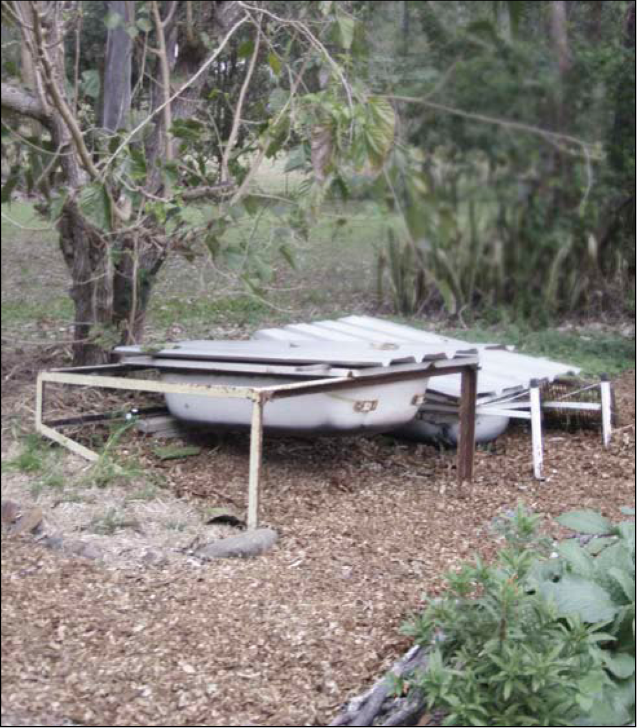

**You Will Need:**

* Bicarbonate soda, vinegar and a scrubbing brush.
* Old bricks, bessar blocks.
* A bathtub.
* A coco peat fibre block.
* Aged horse manure.
* Composting worms - Approximately 2000.
* Chamomile tea and a watering can.
* A length of hessian material.
* A sheet of corrugated iron.
* A collection container.

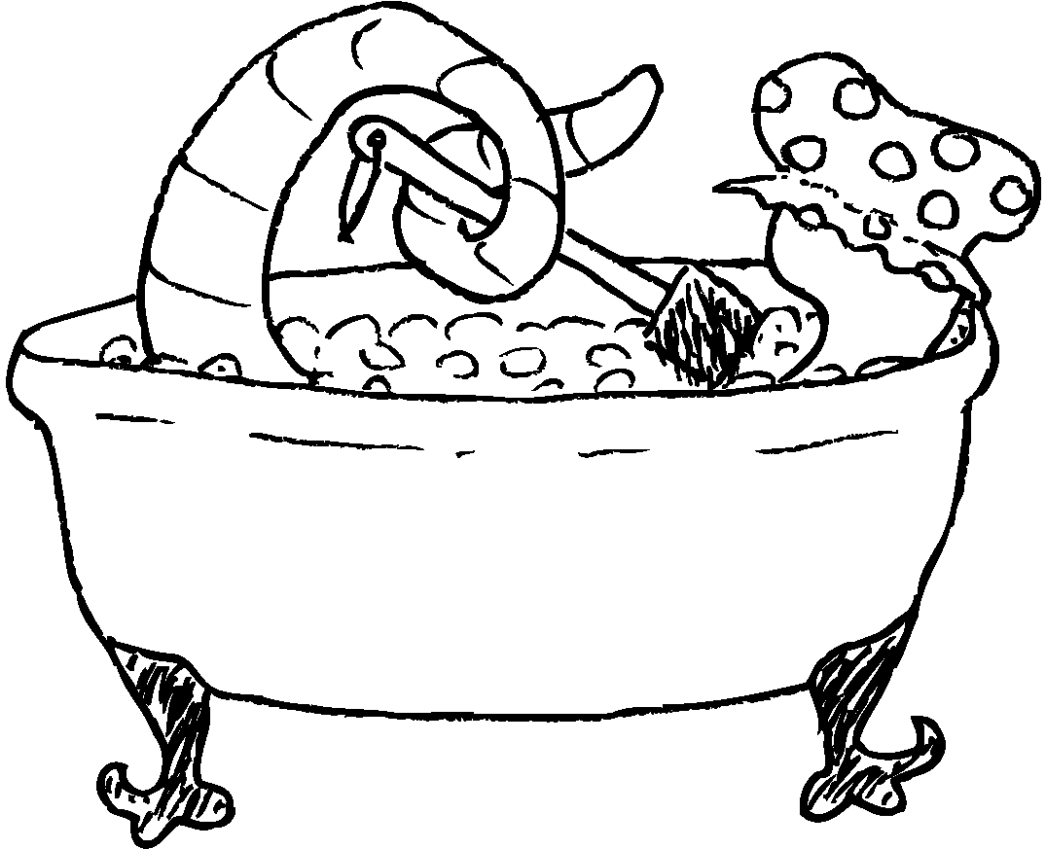

**Step One**

Find a bathtub, either new or used (try your local refuse station), and thoroughly clean and rinse it.

**Step Two**

The bathtub should then be elevated off the earth with bricks with one end sloping back towards the ground. This should be the end with the drain hole in it. A container to catch the “worm tea” should then be placed under the drain hole.

**Step Three**

Place a small piece of shade cloth over the drainage hole.

**Step Four**

Apply:

approximately 150mm in depth of aged (3 months is advisable) horse manure.

Followed by the pre soaked/hydrated coco peat fibre block,

2x 9L buckets of damp shredded newspaper (not highly inked).

Now mix all this together. The bedding material should be damp but not soaking wet. You should be able to pick up some, squeeze it in your hand and a few drops of water drip out.

**Step Five**

Next, the composting worms. Place them in a pile in the middle of the bedding material.

**Step Six**

In a watering can make a batch of cold chamomile tea and lightly sprinkle this over the worm bed to make the bedding slightly moist. This will prevent the formation of moulds etc.

**Step Seven.**

Place the damp hessian directly onto the worms and bedding material. This will keep the moisture in and reduce creepy crawlies and light from entering the worm farm.

**Step Eight.**

The last step is to cover the entire bathtub with a length of corrugated iron, styrofoam, boarding etc to exclude the light, excess rain and unwanted visitors.

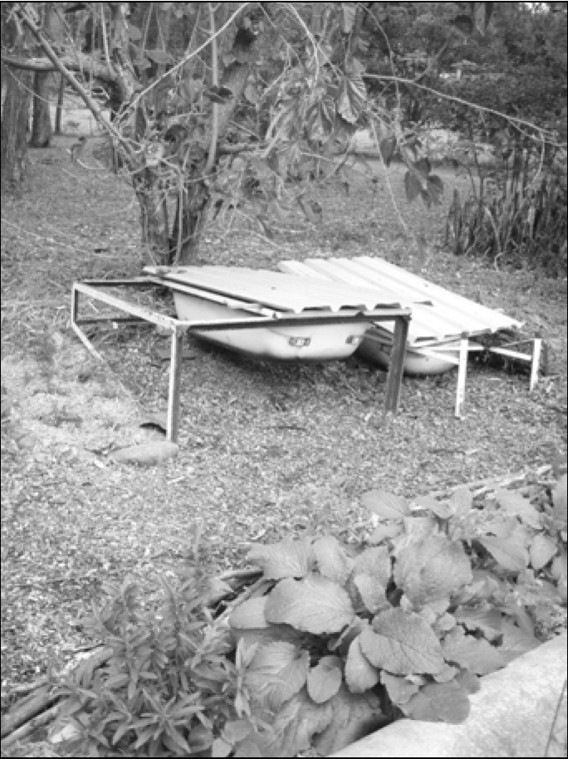

This is an example of the bath tub method. This set up is located under a mulberry tree, which is deciduous, utilising the sun to keep the worm farm warm in winter and shaded in the summer. As you can see in the photo the mulberry tree is just sprouting back its leaves in time for the spring. Chamomile, borage, yarrow and comfrey are all grown near the worm farm. These are all useful herbs for the health of the worm farm, the compost heap and for yourself.