April.
Vegetable planting options:
Asparagus crowns, asian greens, beetroot, broccoli, cabbage, carrot, cauliflower, celeriac, celery, chicory, corn salad, coriander, endive, garlic, horseradish, kale, kohlrabi, leek, lettuce, miners lettuce, onion, orach, peas/snow peas, parsnip, potato, radicchio, radish, salsify, silverbeet, spinach- mountain, perpetual and winter varieties, spring onion, shallots, sunflowers, strawberry, tomatoes, turnip.
Available for harvest:
Asian greens, beans, beetroot, cape gooseberry, capsicum, choko, cucumber, eggplant, endive, horseradish, lettuce, luffa, melons, okra, pumpkin, radish, rosella, salsify, spring onion , silverbeet, spinach- mountain, perpetual and ceylon, spring onion, squash, strawberry , sunflowers, swede, sweet corn, tomato ,turnip, zucchini.
Maintenance tasks include:
Time to weed and thin out the existing crops.
Last chance to plant green manure crops in preparation for the autumn/winter leaf vegetables if you have not already done so.
Give the worm farm an end of month feed of “Unprocessed Bran“ to help with their digestion.
Aerate the worm farm.
At the start of the month sit down and plan out your autumn/winter vegetable garden.
Keep planting those companion flowers. The wider the diversity of flowers, the wider the diversity of good insects.
Continue to collect white bread tags and peanut shells for future use in repelling unwanted insects.
Start to plant “Mothers Day” flower or herb bowls at the start of the month to allow them time to establish.
Remember not to over plant your vegetable garden. Air flow should be your new mantra!
If you choose to plant Daffodils or tulips from bulbs in a sub-tropical climate, place them in the chiller section of the refrigerator for approximately 3-6 weeks prior to planting. This will encourage greater flowering.

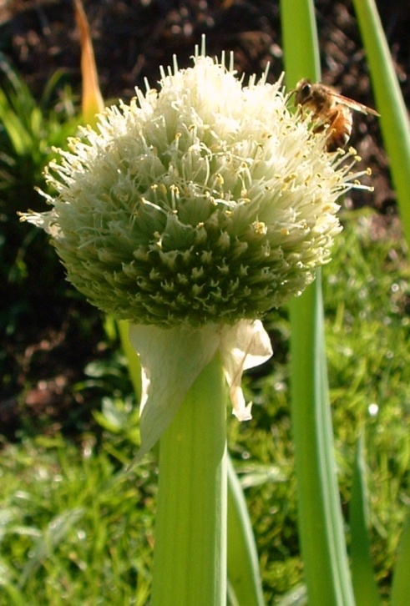
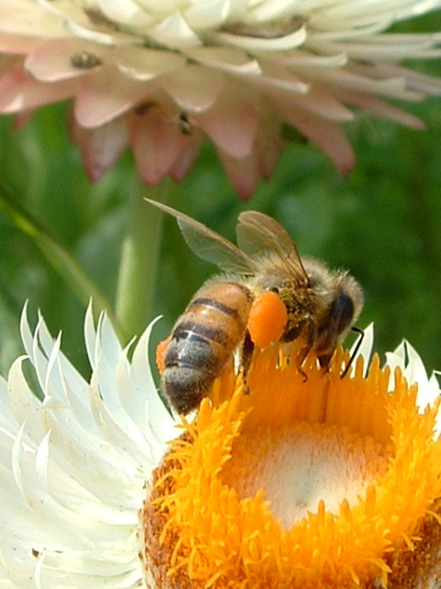
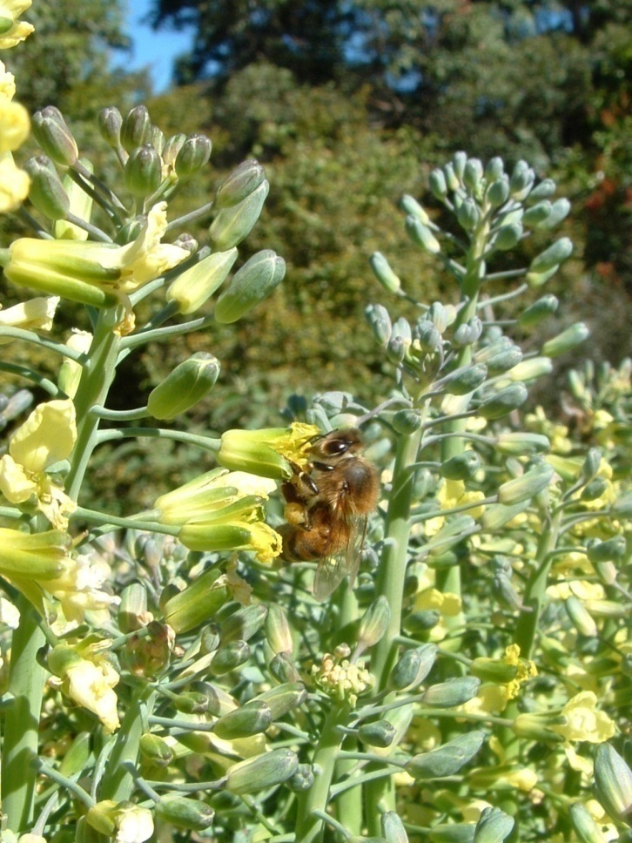
Bees are vital for a productive vegetable garden. Try letting some vegetables go to seed and planting bee attracting flowers in your garden.

Strawberry - Fragaria x ananassa.
Origin: North America.
Family: Rosaceae.
Growing conditions:
- Plant strawberry runners in subtropical areas March - April. In cooler areas - late winter or early spring.
- Each strawberry plant will produce for approximately 2 to 3 years.
- Choose an open, sunny position for the strawberry bed as good airflow will reduce fungal problems such as grey mould.
- Strawberries prefer a well-drained soil, rich in humus that is slightly acidic.
How to grow:
- Make raised mounds or speed bump shaped planting beds. Be sure to have plateau style mounds not pyramids. By having the mounds flat at the top (at least 300mm width) you will enable water to be soaked into the soil rather than washed down a hill (pyramid style). More airflow is achieved and the fruit can sit gently down the sides rather than on the flat ground.
- Space the runners approximately 30 cm apart in a zigzag design to allow more air flow between them.
- Strawberries enjoy an ample supply of water but dislike wet leaves. Water in the mornings and avoid watering the leaves. Aim the hose for the base of the plants. A dripper watering system is perfect for strawberry crops.
- If you can get your hands on pine needles use these as a mulch. If not, sugar cane with a slight amount of wood mulch mixed through will be sufficient.

When to harvest:
- You'll find most strawberries flower in spring and then set fruit in late spring/early summer.
- Only choose plump, firm, completely red berries. Unripe berries will not ripen once they are picked.
- Grasp the berry between your thumb and forefinger and snap the stem with a twisting motion, or, cut the stem above the berry with scissors.
- You can easily freeze berries that you don’t eat straight away. Simply wash, cut the hulls off them and place the berries into an airtight bag. Remove as much air as possible from the bag.

Common problems:
- Common pests include: snails, slugs, two spotted mite, thrips, possums, birds and even the occasional pet dog.
- Common disease can include: fungal diseases such as - powdery mildew, black spot, leaf blight, and leaf spot.

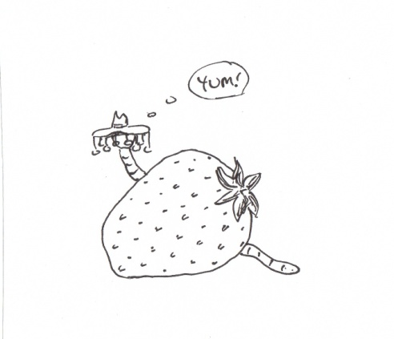

Pumpkin Spice Loaf.

Perfect for morning teas or a treat for the school lunch box.
INGREDIENTS:
250 grams x butter.
¾ x Cup of raw sugar.
2 x eggs – lightly beaten.
1 x Cup of chopped dates and/or sultanas.
½ x Cup of desiccated coconut.
1 x Cup of pumpkin which had been roasted, let to cool and mashed.
2 x Cups of self raising flour.
1 x Tsp of nutmeg.
½ x Tsp of ground cinnamon.
1/3 x Cup of milk.

METHOD:
- Using an electric mixer cream the butter and sugar together until light and fluffy.
- Gradually beat in the eggs.
- Transfer mixture to a large bowl and mix in dates and/or sultanas, coconut and pumpkin.
- Fold in sifted flour and spices alternately with the milk.
- Pour into a medium sized loaf tin and bake for approximately 1 ¼ hours on 180 degrees Celsius.
- Let stand in the tin for 10 minutes and then turn onto a wire rack to cool.

Pumpkin and Rosemary Cookies.
One of my all time favourite biscuits that happens to be gluten, wheat and dairy free.
INGREDIENTS:
1/2 x Cup of raw sugar.
½ x Cup of salad oil.
2 x Tbsp of chopped fresh rosemary.
2 x Cups of self raising flour.
½ x Tsp of ground cinnamon.
½ x Tsp of ground ginger.
1 x Cup of baked, cooled then mashed pumpkin.
1 x Tsp vanilla essence.
1 x Cup of sultanas.
½ x Tsp of nutmeg.
METHOD:
- Preheat the oven to 180 degrees Celsius and grease or line a baking tray.
- In a large bowl beat the sugar, pumpkin, oil and vanilla.
- Add the sultanas and rosemary.
- Sift all the dry ingredients together then add to the pumpkin mix.
- Mix together well.
- Drop spoonfuls onto the greased baking tray and bake in the oven for approximately 20 – 30 minutes or until golden brown. Makes approximately 24 cookies.
Recipe kindly donated by: www.herbcottage.com.au

April Planting Notes and Observations.

What grew well?
______________________________________________________________________________________________________________________________________________________________________________________________________________________________________________________
What didn’t grow well?
______________________________________________________________________________________________________________________________________________________________________________________________________________________________________________________
Pest and disease problems?
______________________________________________________________________________________________________________________________________________________________________________________________________________________________________________________
What is an option to try something differently next year?
______________________________________________________________________________________________________________________________________________________________________________________________________________________________________________________
General notes.
________________________________________________________________________________________________________________________________________________________________________________________________________________________________________________________________________________________________________________________________________________________________________________________________________________________________________________________________________________________________________________________________________________________________________________________________________________________________________________________________________________

A salad can include: a mixed variety of leafy greens, herbs and even flowers.
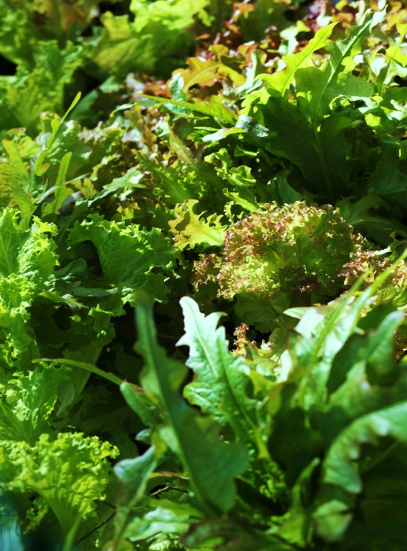
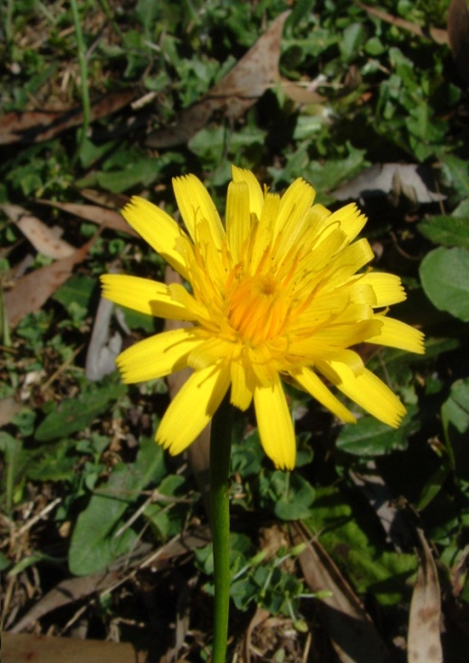
Mixed greens. Dandelions.
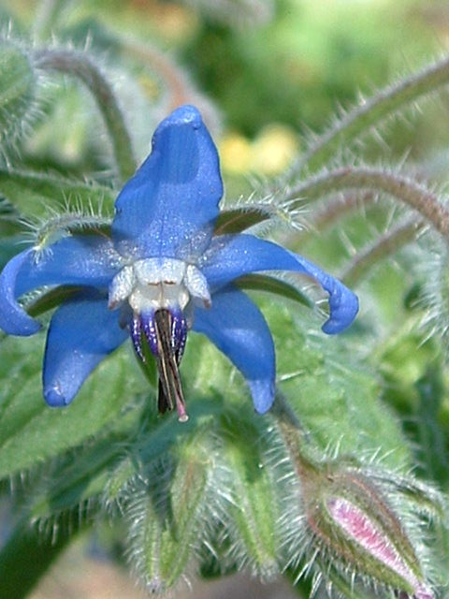
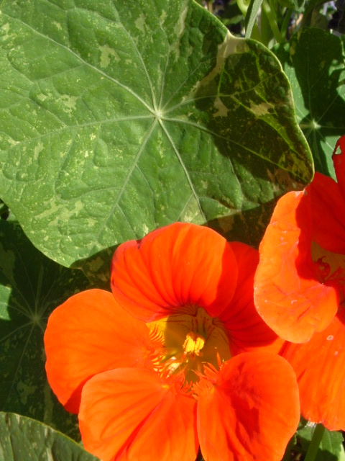
Borage. Nasturtiums.

